**INF10025 Data Management and Analytics**

# Task 3 – Credit Submission

Student Number: 104071453  
Student Name: Marco Giacoppo

### Credit 3a

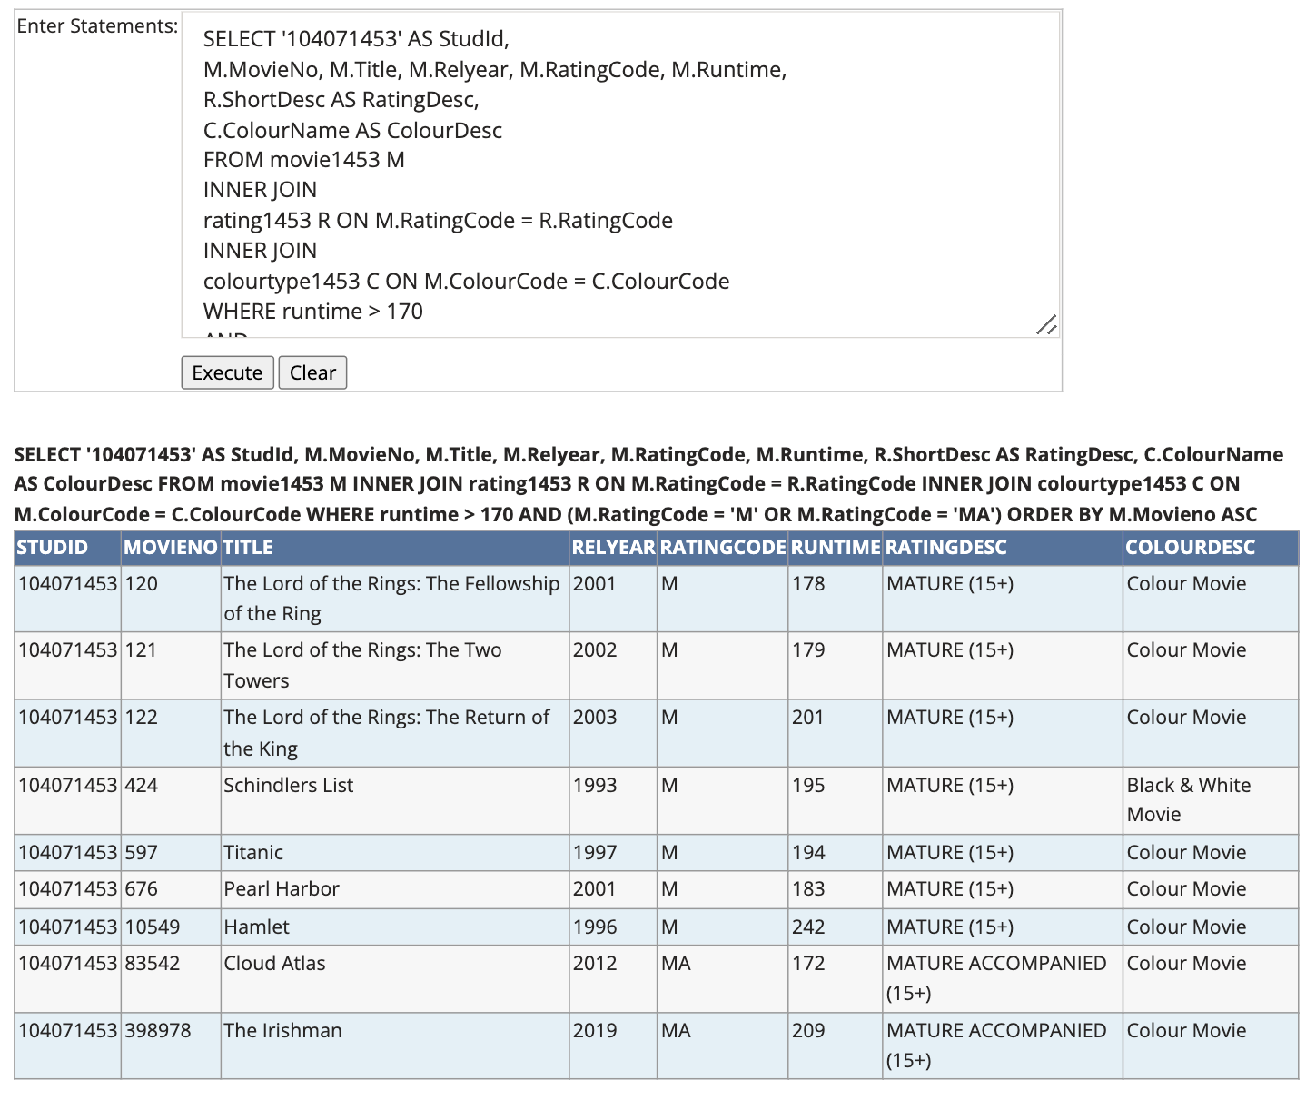

### Credit 3b

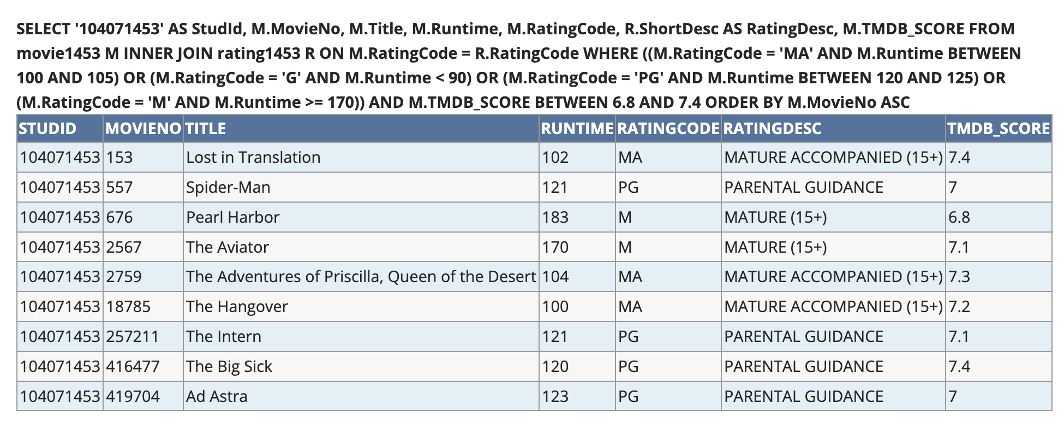

### Credit 3c

### Credit 3d

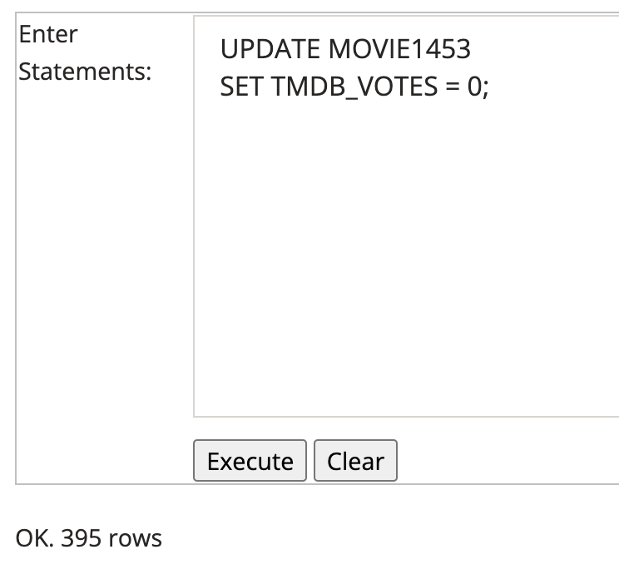

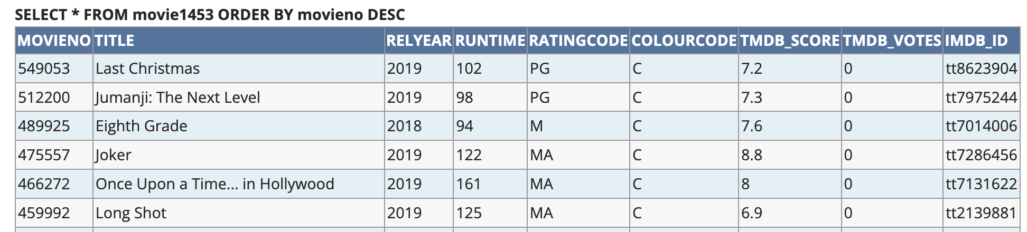

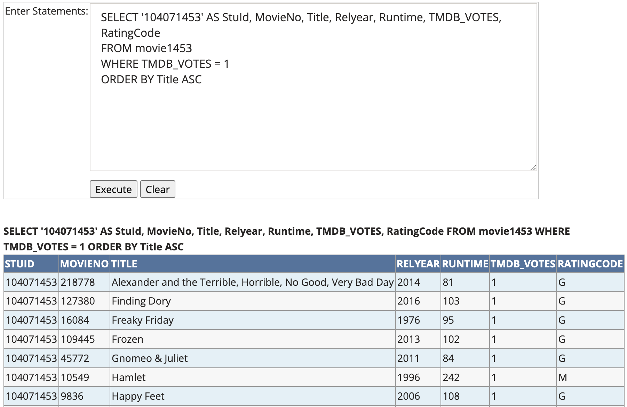

### Credit 3e

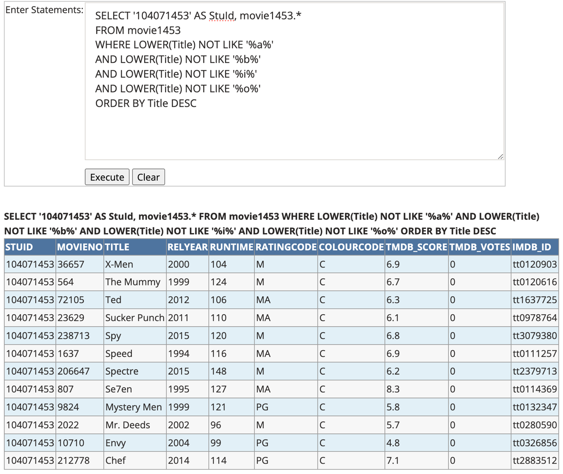

### Credit 3f

Relational Schema:

Create_car_sql.txt:

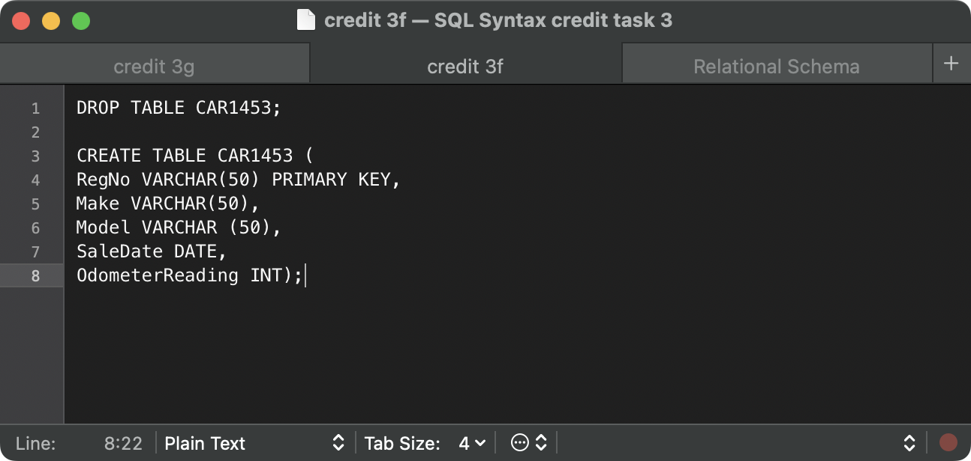

### Credit 3g

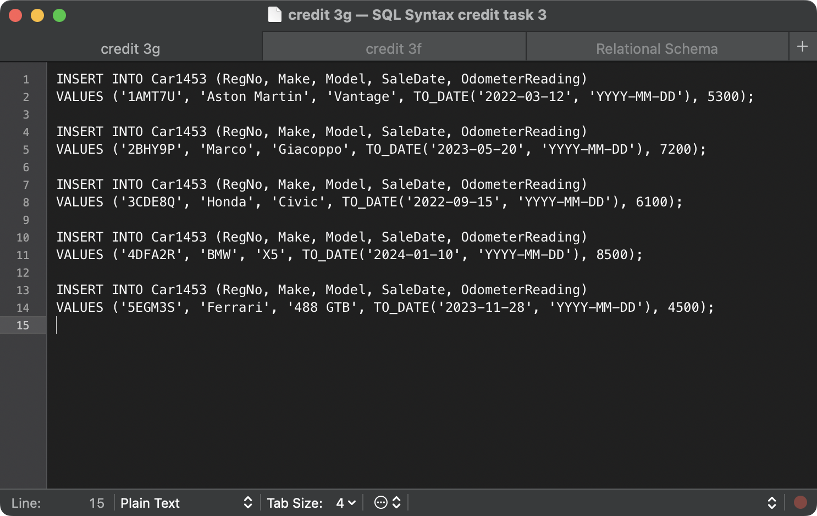

### Credit 3h

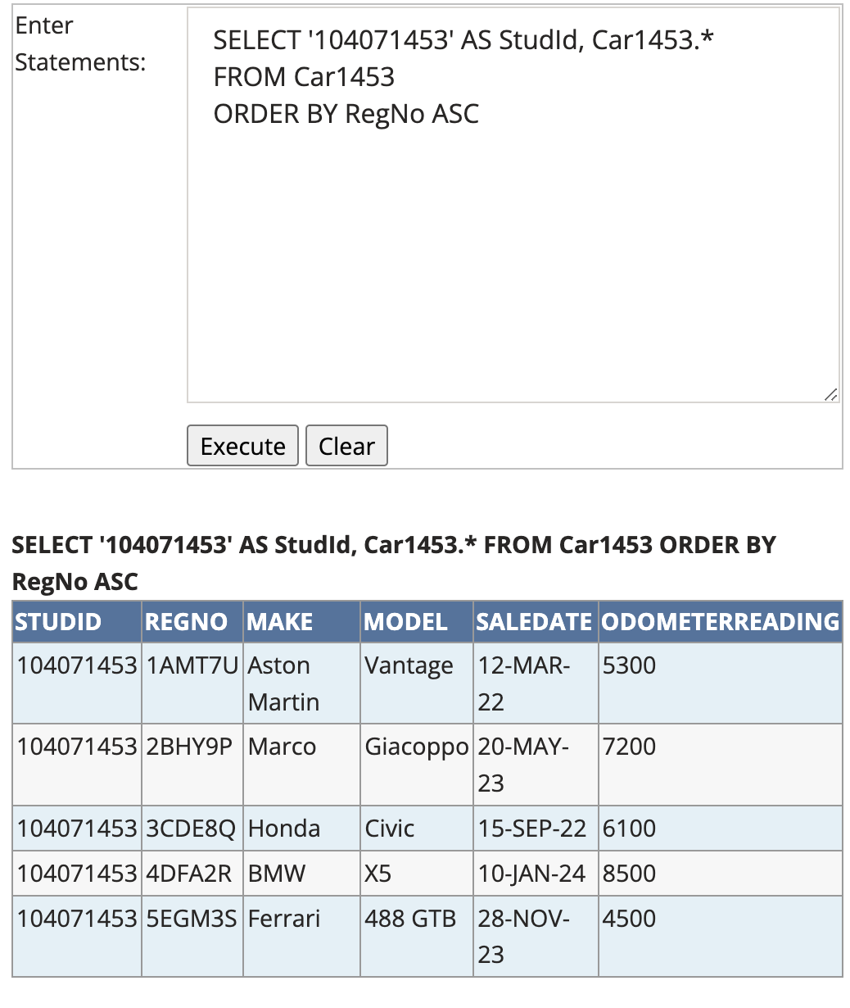

### Credit 3i

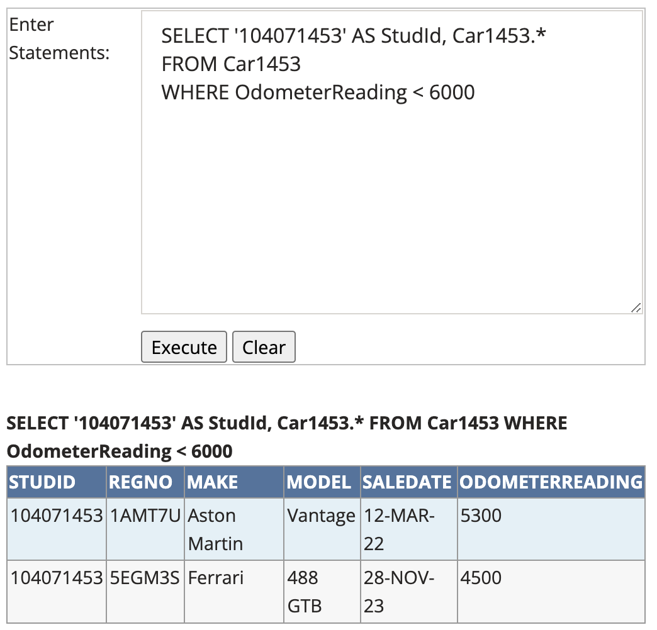

### Credit 3j

